1 Neural Network Playground

* 1. Hand-crafted Feature Engineering

Circle

Weight: x1^2 -0.35 x2^2 -0.36

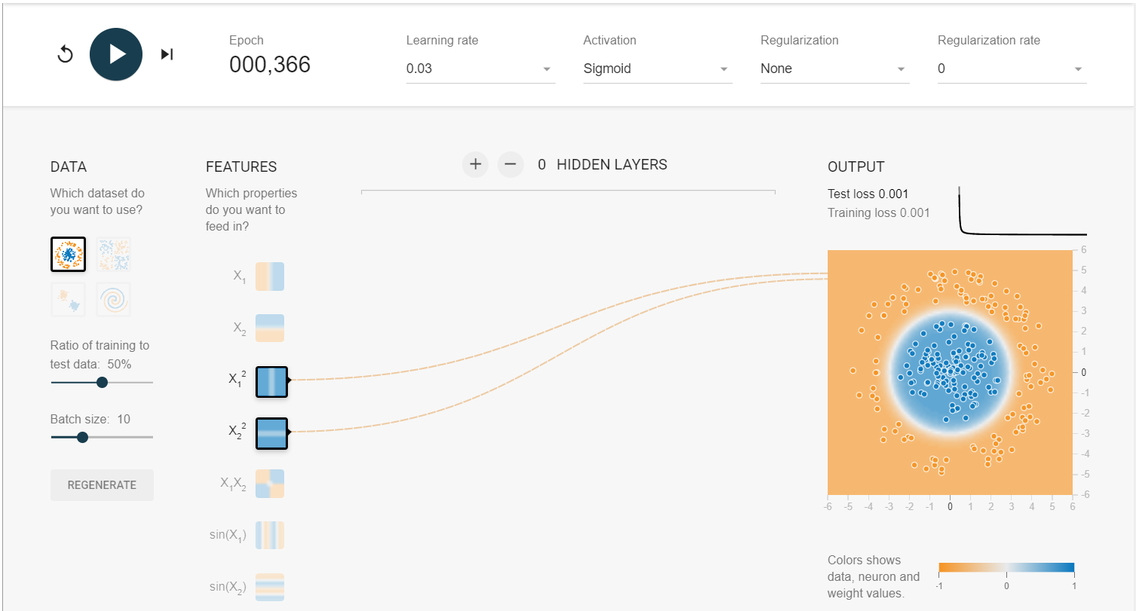

Exclusive Or

Weight 2.8

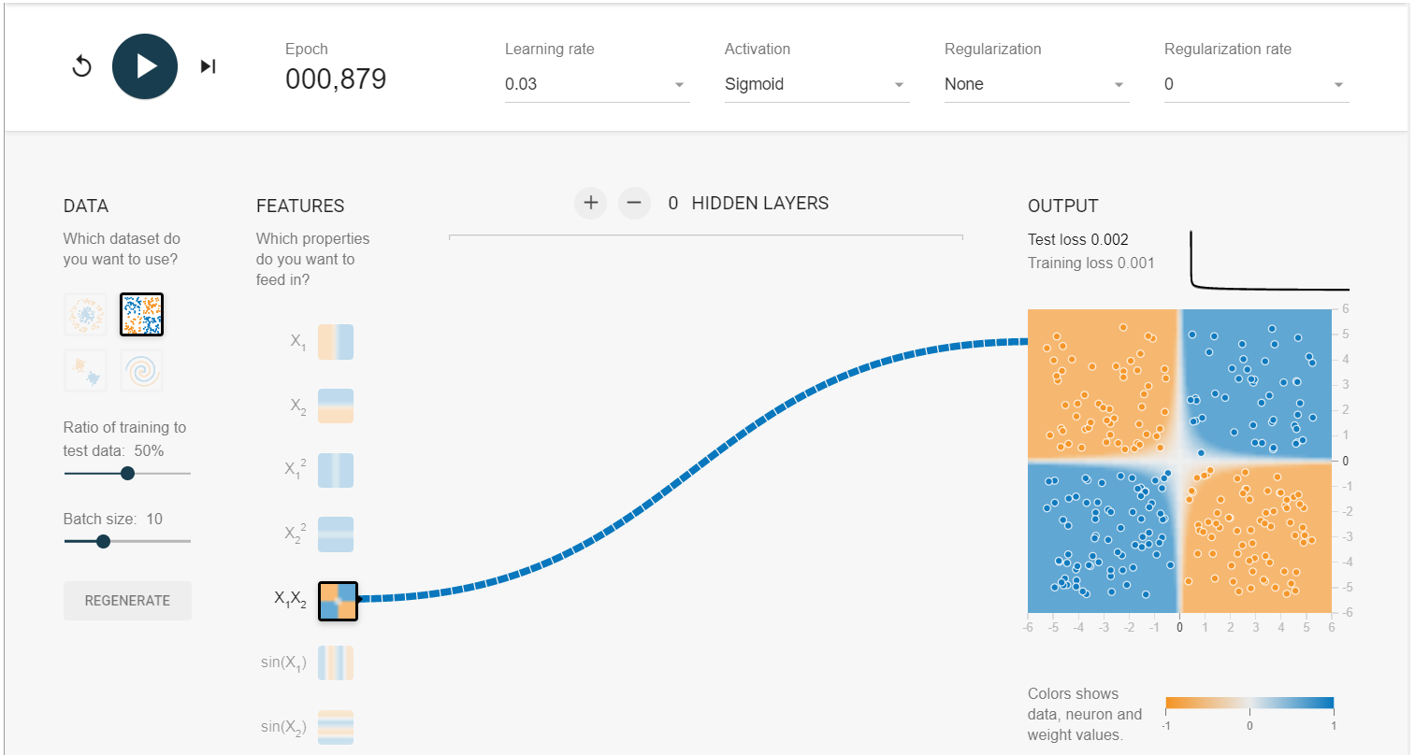

Gaussian

0.88 0.70

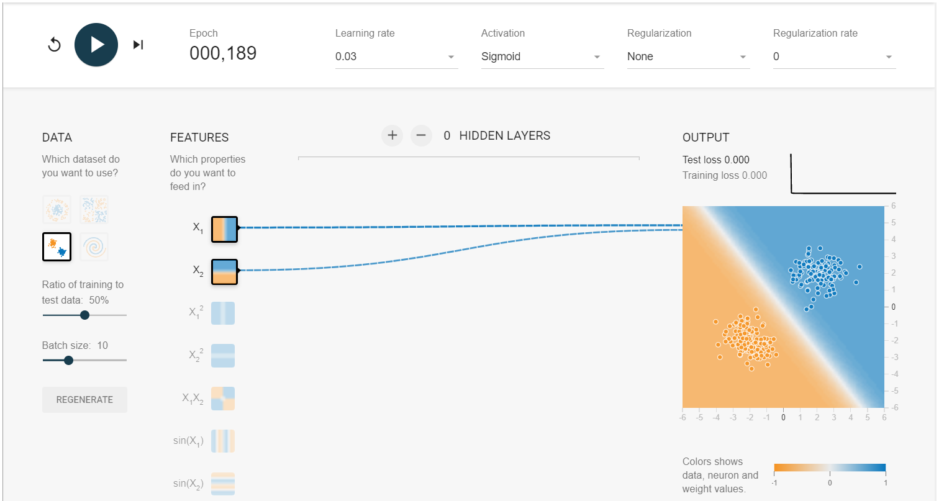

Spiral

-0.13

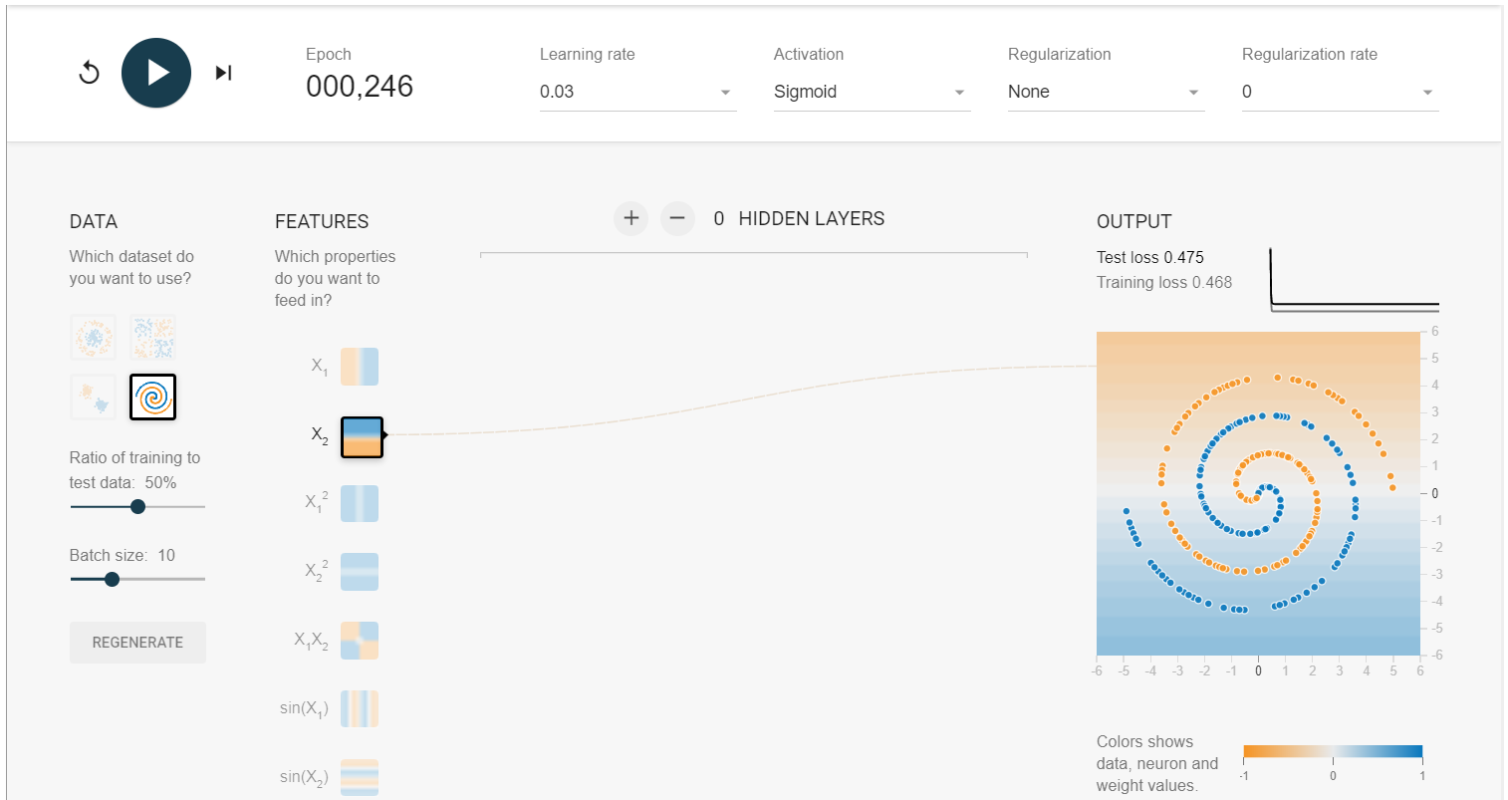

* 1. Regularization

Circle

No

-0.022 0.024 -0.39 -0.38 -0.0030 -0.048 0.020

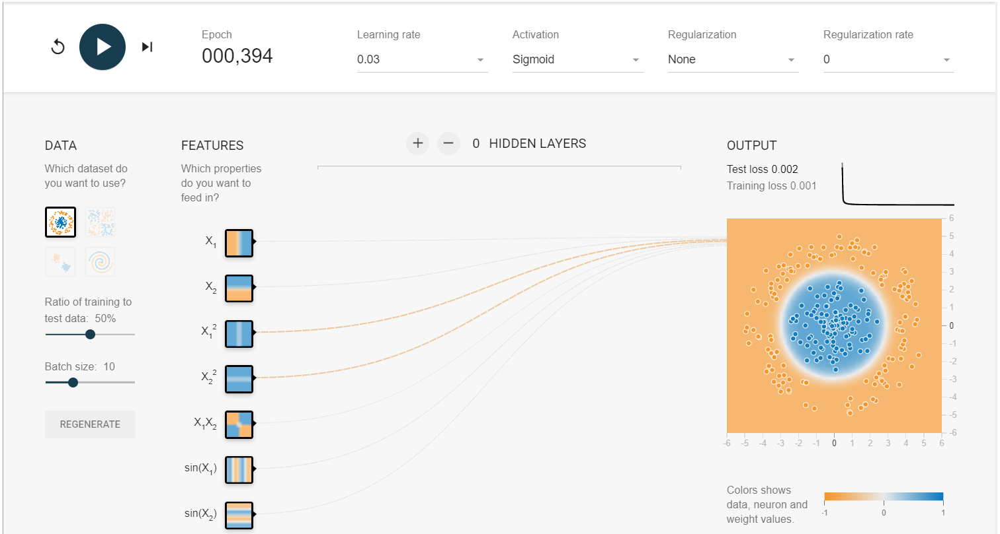

L1 0.003

[0 0 -0.38 -0.37 0 0 0]

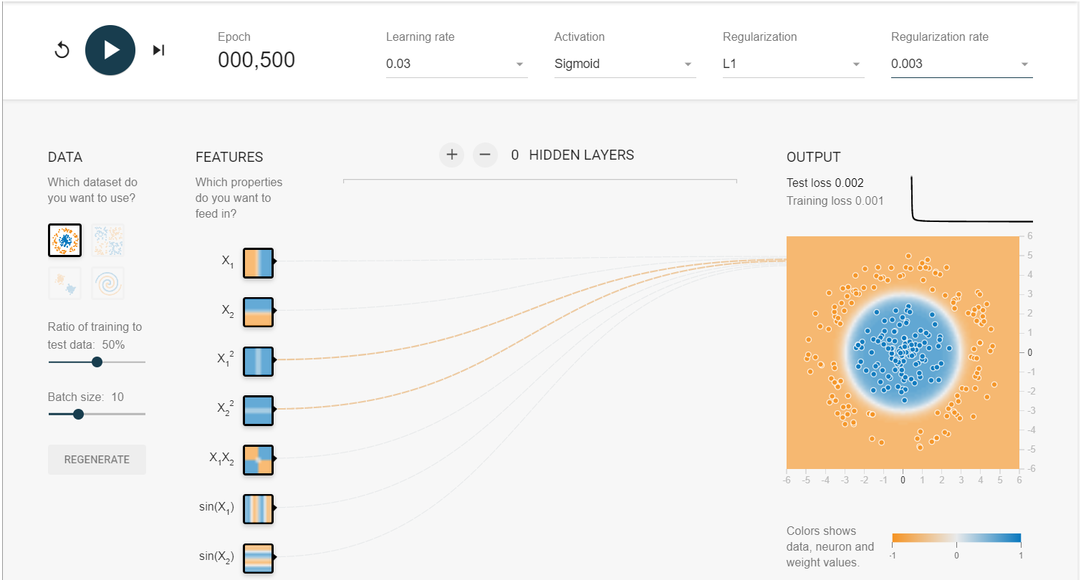

L2 0.003

[-0.023 0.024 -0.39 -0.38 -0.0038 -0.0034 0.0014]

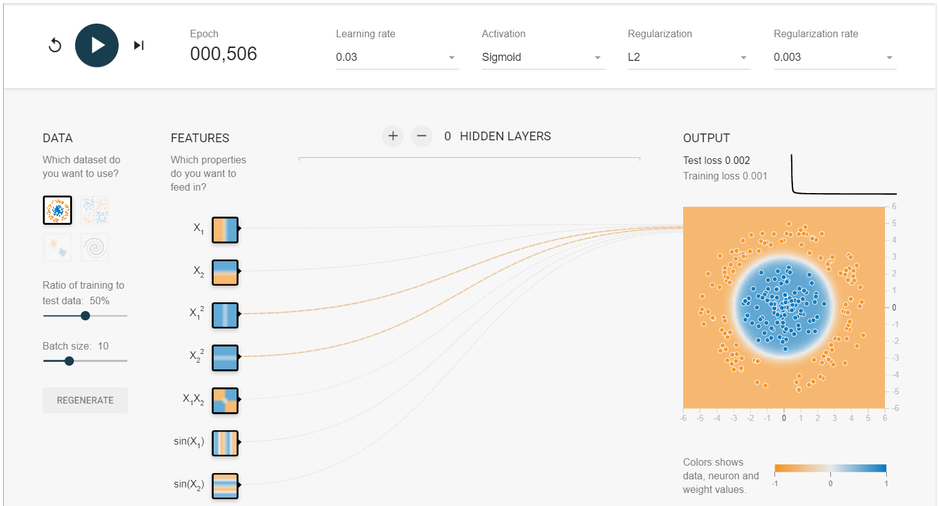

Exclusive Or

No

[0.10 0.041 -0.087 0.087 2.0 0.088 0.12]

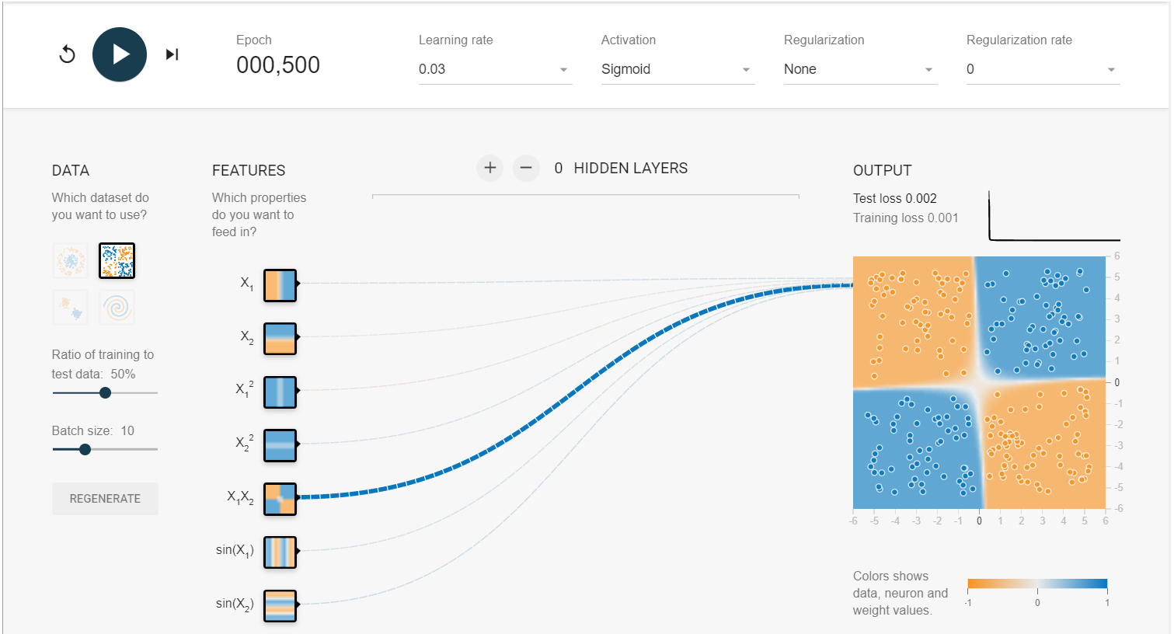

L1 0.003

[0 0 0 0 1.5 0 0]

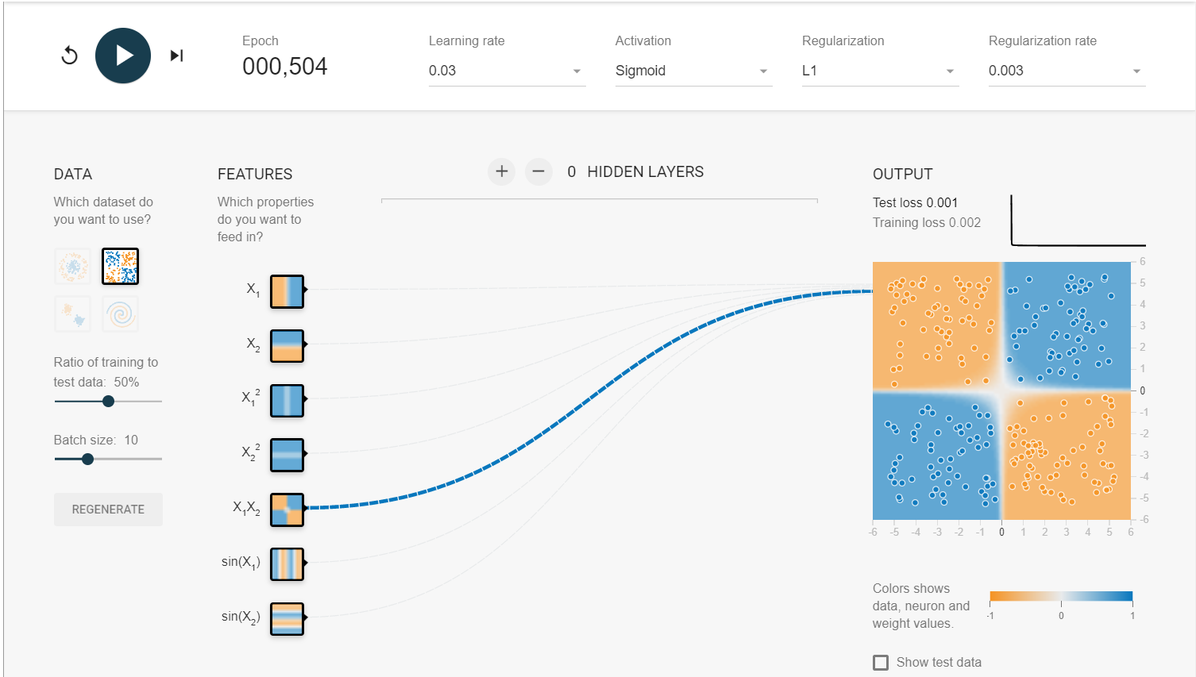

L2 0.003

[0.014 0.057 -0.035 0.052 1.4 0.11 0.031]

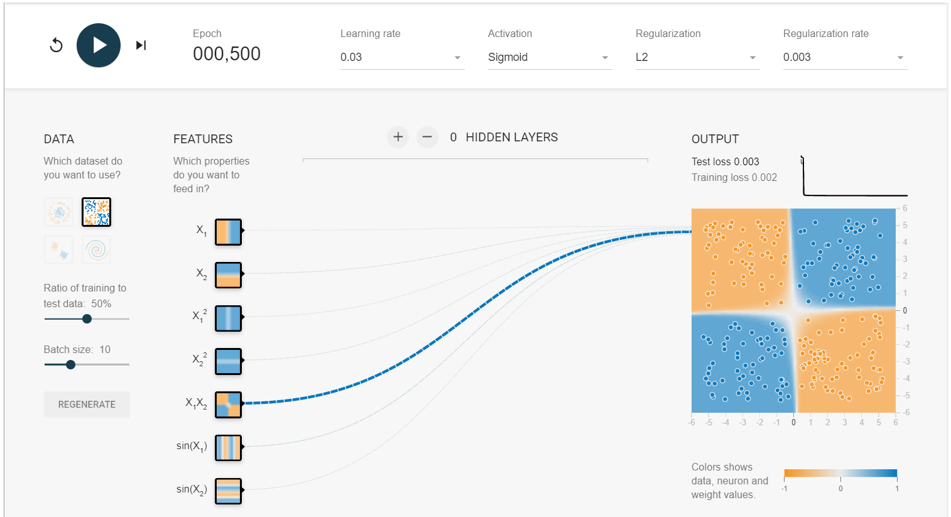

Gaussian

No

[0.55 0.88 -0.072 -0.13 0.28 0.14 0.72]

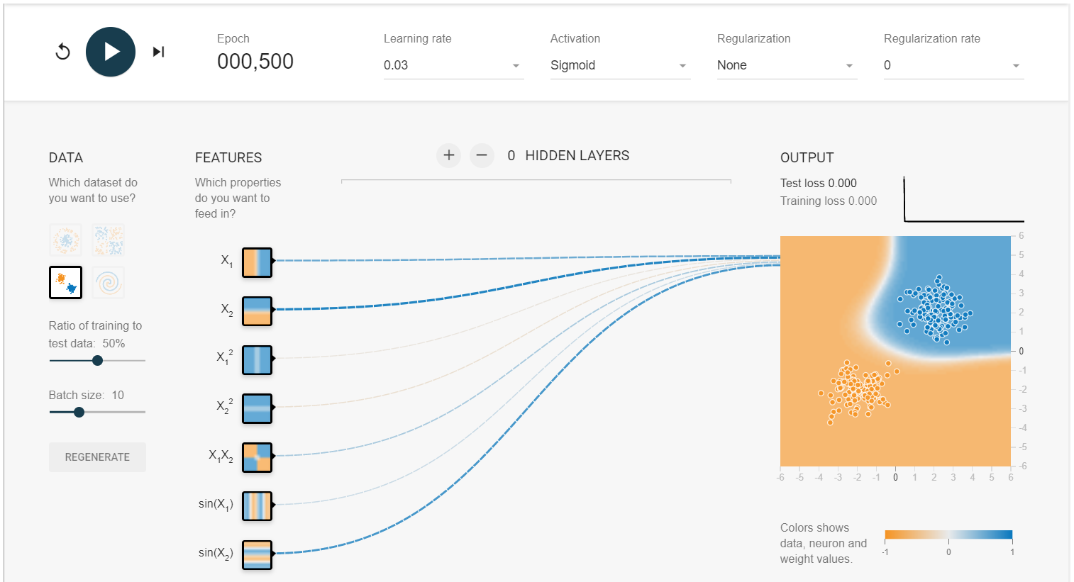

L1 0.003

[0.42 0.68 0 0 0 0 0.30]

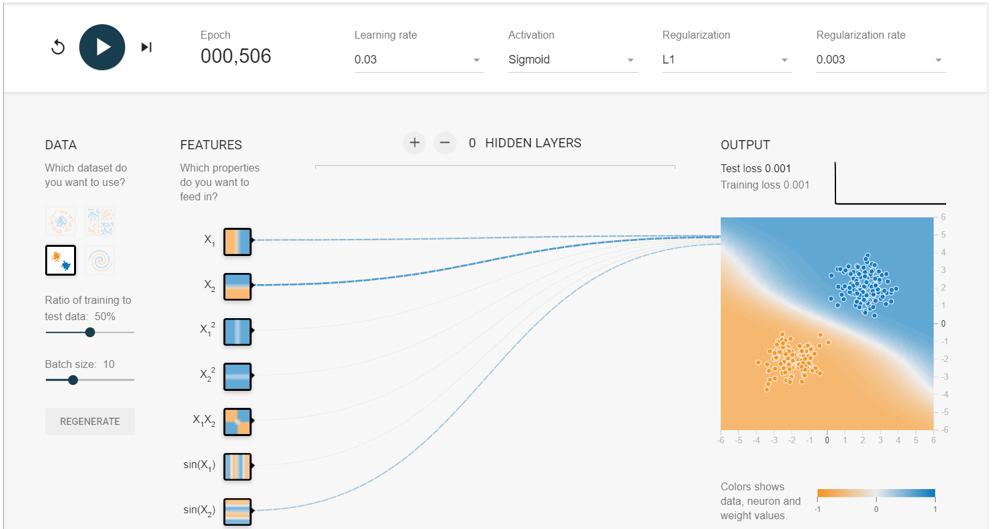

L2 0.003

[0.48 0.57 0.0035 0.016 0.0077 0.26 0.42]

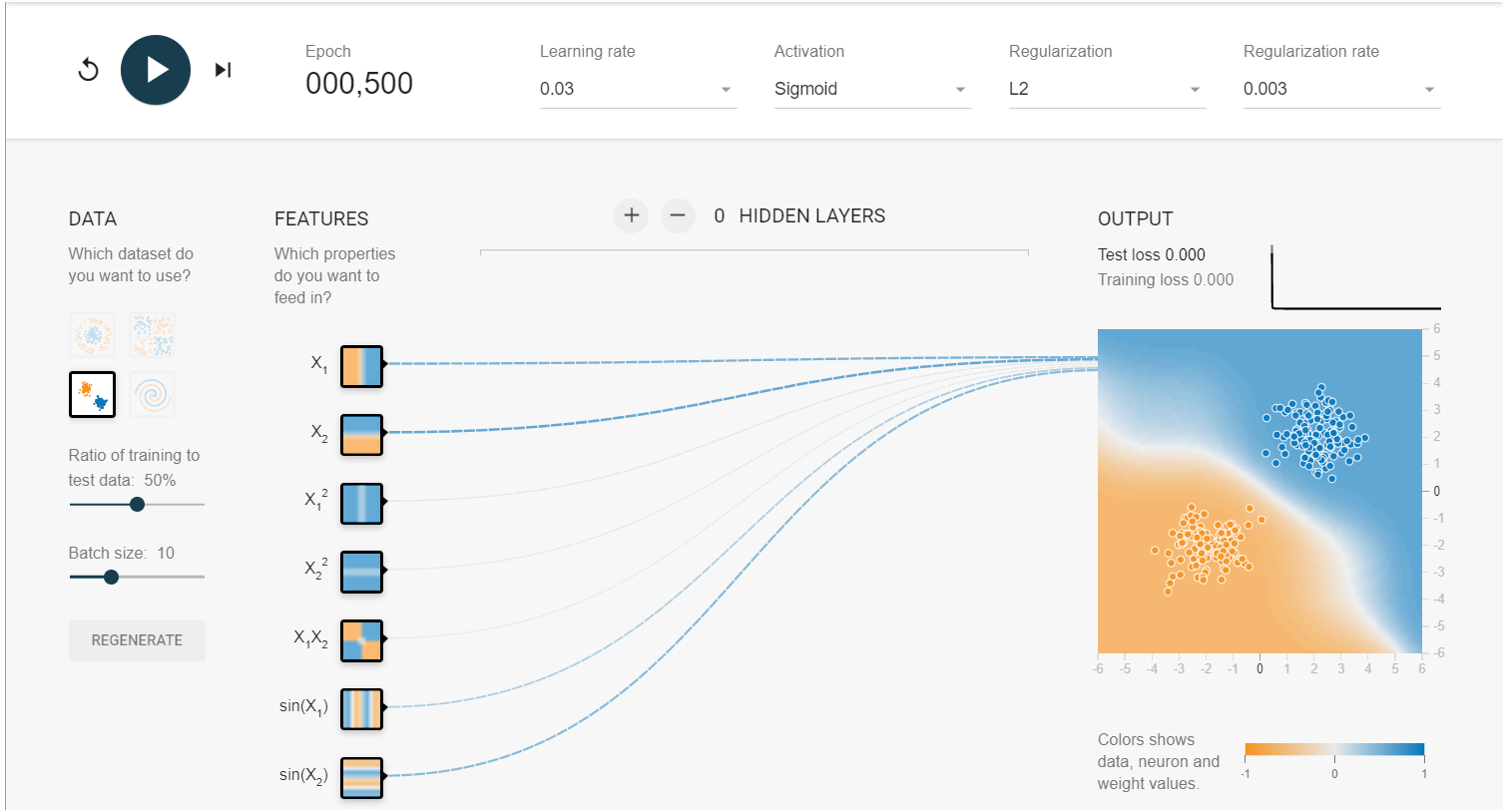

* 1. Automated Feature Engineering with Neural Network

the Circle

|  |  |  |  |  |  |  |
| --- | --- | --- | --- | --- | --- | --- |
| No | activation | Layer1 | Layer2 | Train loss | Test loss | iterations |
| 1 | sigmoid | 3 | \ | 0.014 | 0.012 | 1000 |
| 2 | relu | 3 | \ | 0.007 | 0.002 | 1000 |
| 3 | sigmoid | 4 | \ | 0.010 | 0.010 | 1200 |
| 4 | relu | 4 | \ | 0.003 | 0.006 | 700 |
| 5 | sigmoid | 8 | \ | 0.006 | 0.007 | 1200 |
| 6 | relu | 8 | \ | 0.000 | 0.001 | 1000 |
| 7 | sigmoid | 8 | 2 | 0.006 | 0.009 | 1000 |
| 8 | relu | 8 | 2 | 0.000 | 0.001 | 400 |
| 9 | sigmoid | 8 | 4 | 0.006 | 0.007 | 1000 |
| 10 | relu | 8 | 4 | 0.000 | 0.001 | 400 |

Sigmoid is very slow

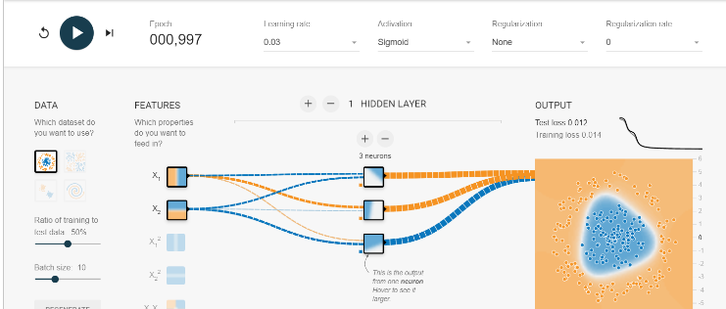

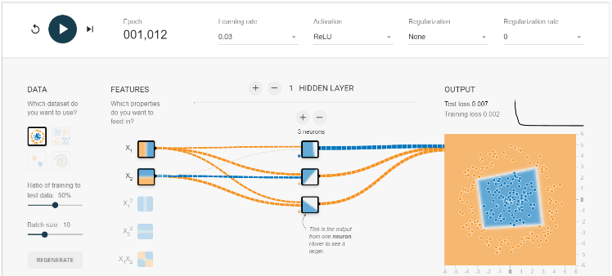

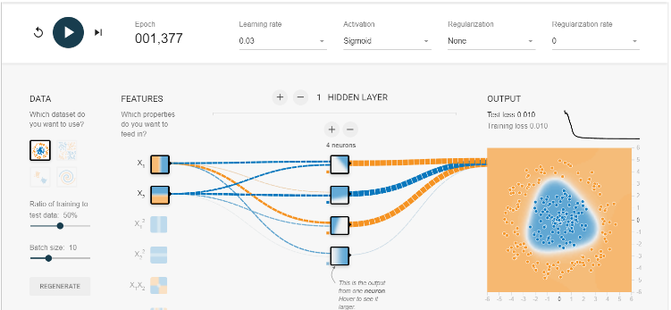

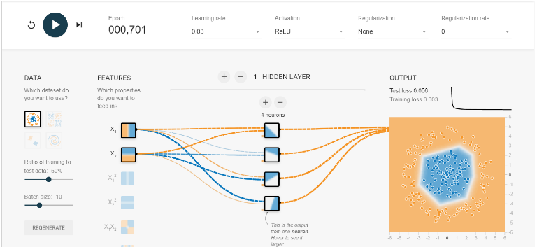

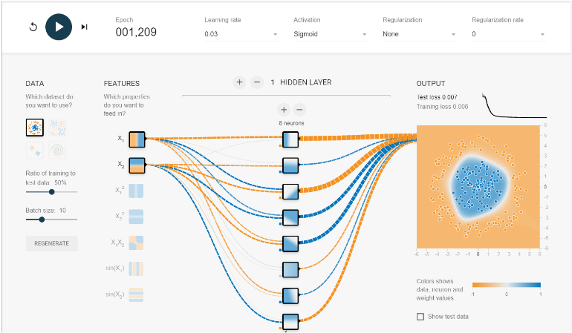

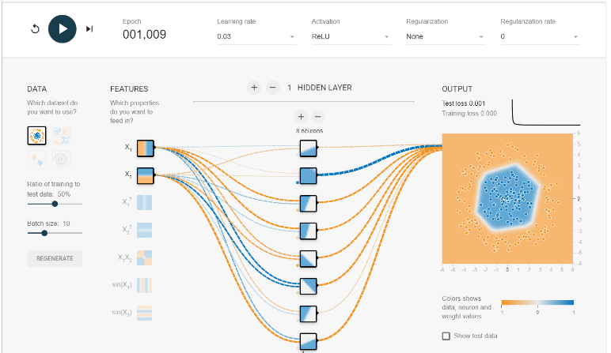

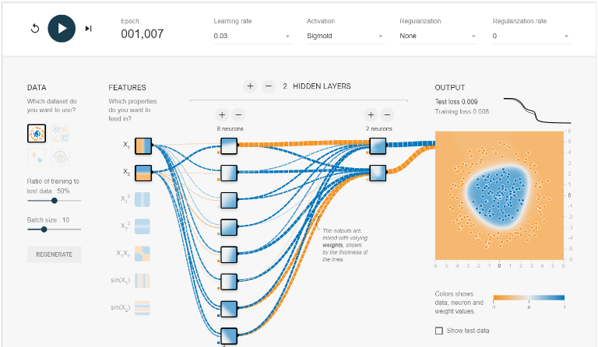

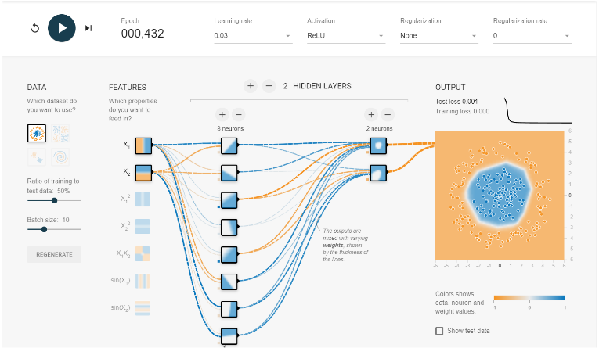

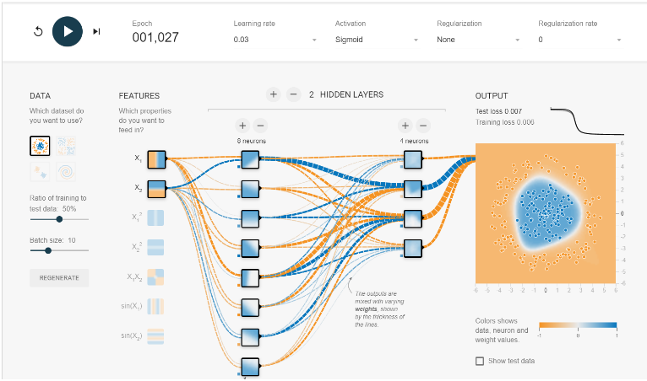

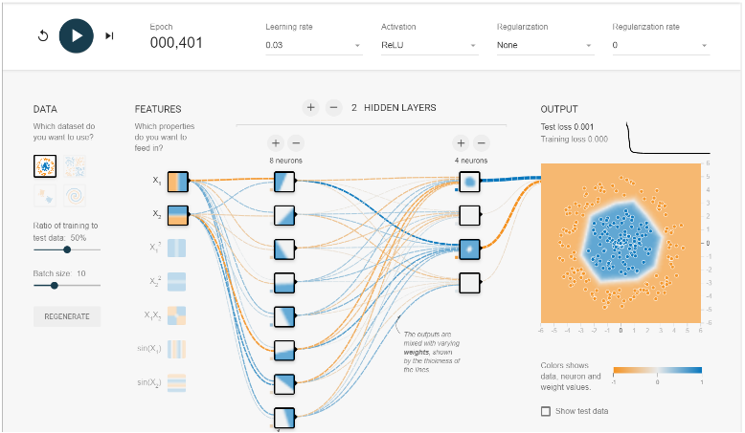

Exclusive Or

|  |  |  |  |  |  |  |
| --- | --- | --- | --- | --- | --- | --- |
| No | activation | Layer1 | Layer2 | Train loss | Test loss | iterations |
| 1 | sigmoid | 3 | \ | 0.067 | 0.073 | 800 |
| 2 | relu | 3 | \ | 0.001 | 0.005 | 600 |
| 3 | sigmoid | 4 | \ | 0.016 | 0.028 | 1000 |
| 4 | relu | 4 | \ | 0.002 | 0.005 | 650 |
| 5 | sigmoid | 8 | \ | 0.012 | 0.022 | 1000 |
| 6 | relu | 8 | \ | 0.000 | 0.001 | 600 |
| 7 | sigmoid | 8 | 2 | 0.006 | 0.011 | 1000 |
| 8 | relu | 8 | 2 | 0.000 | 0.000 | 400 |
| 9 | sigmoid | 8 | 4 | 0.002 | 0.005 | 1000 |
| 10 | relu | 8 | 4 | 0.000 | 0.000 | 400 |

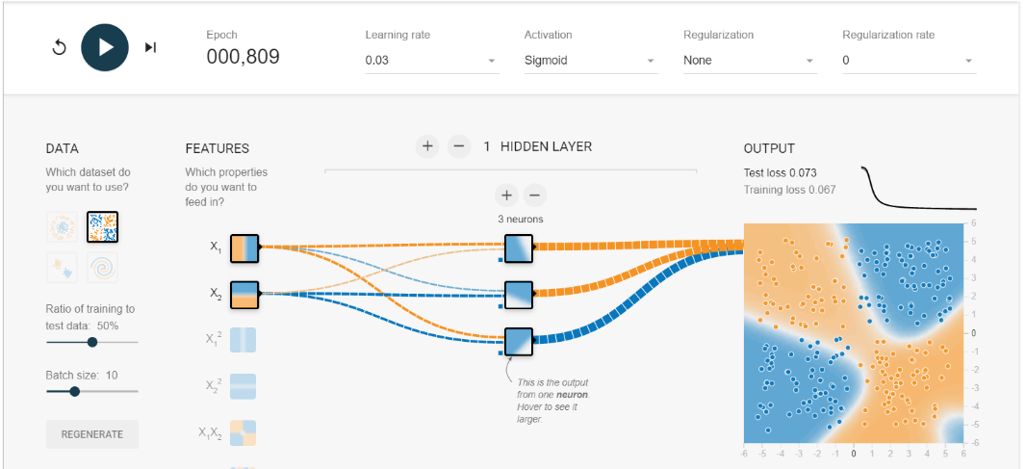

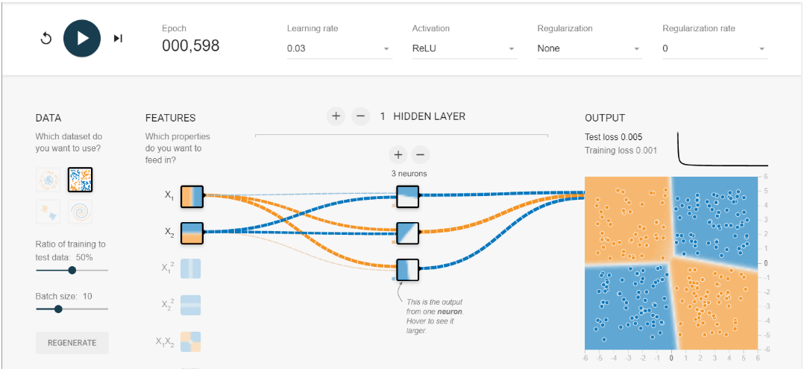

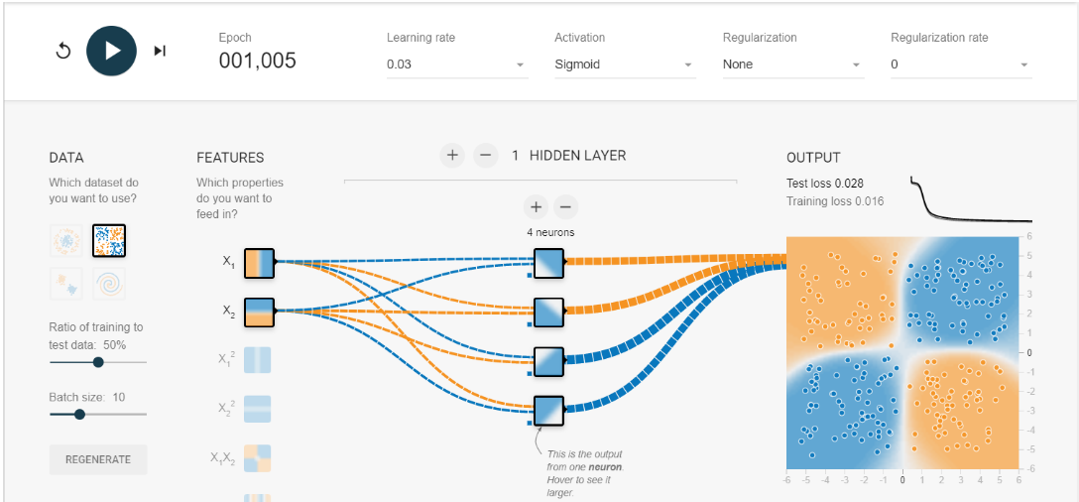

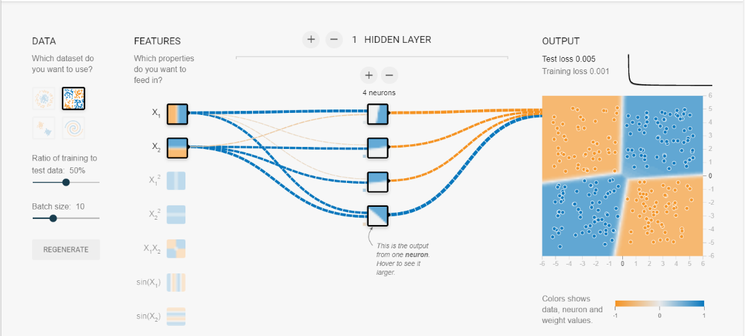

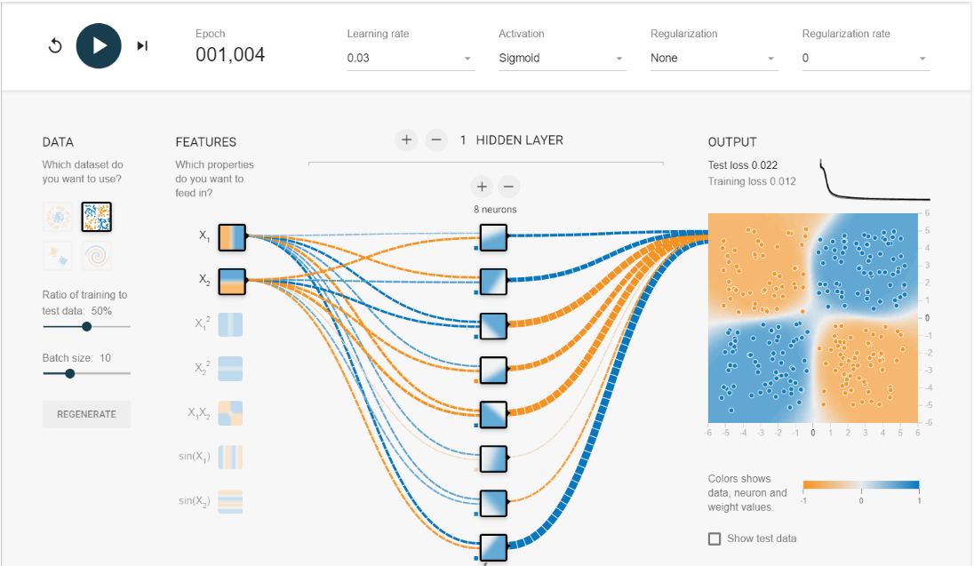

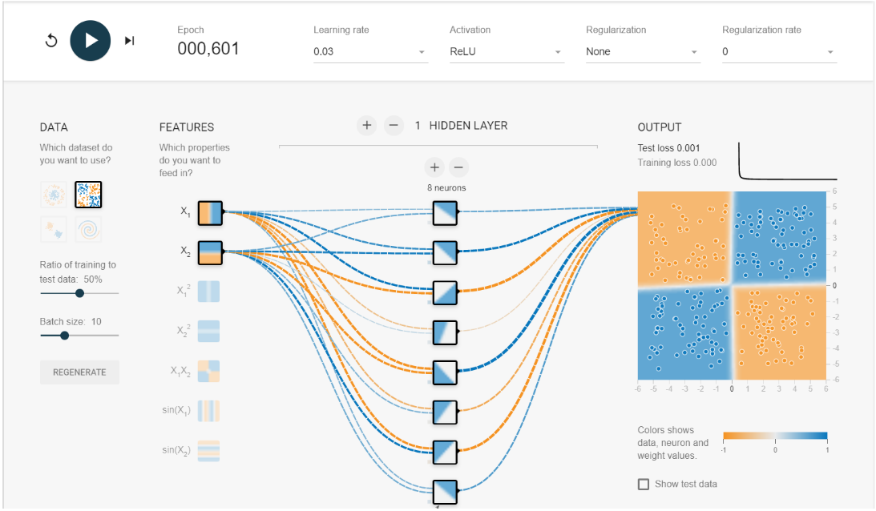

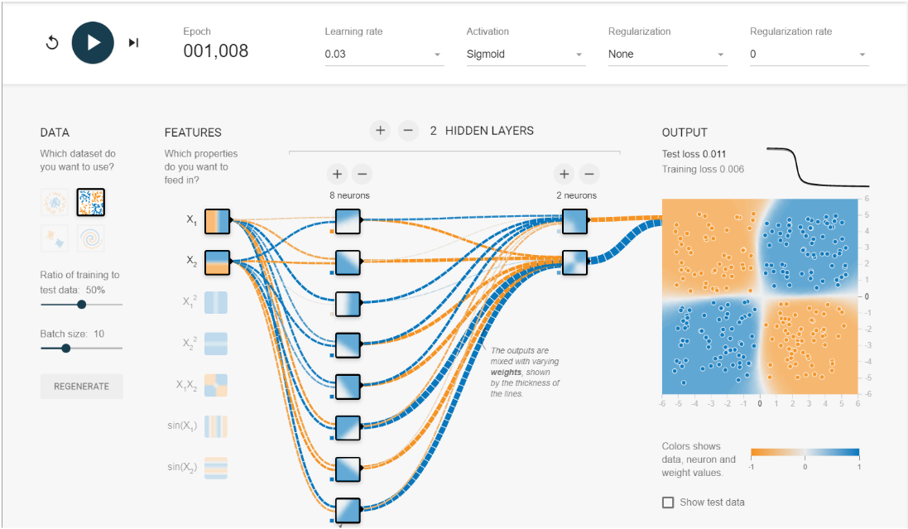

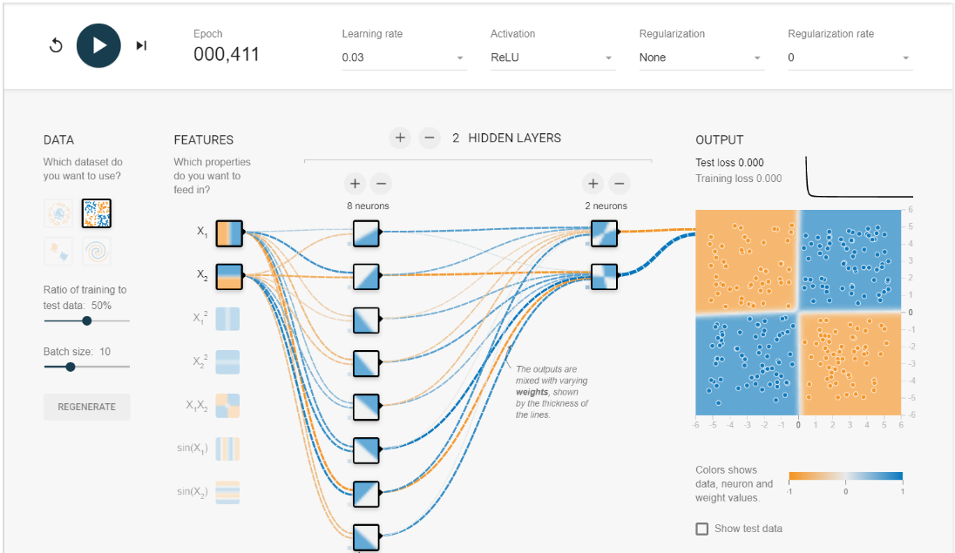

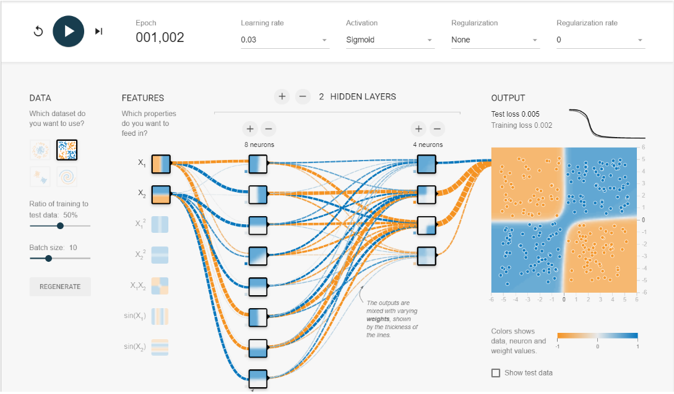

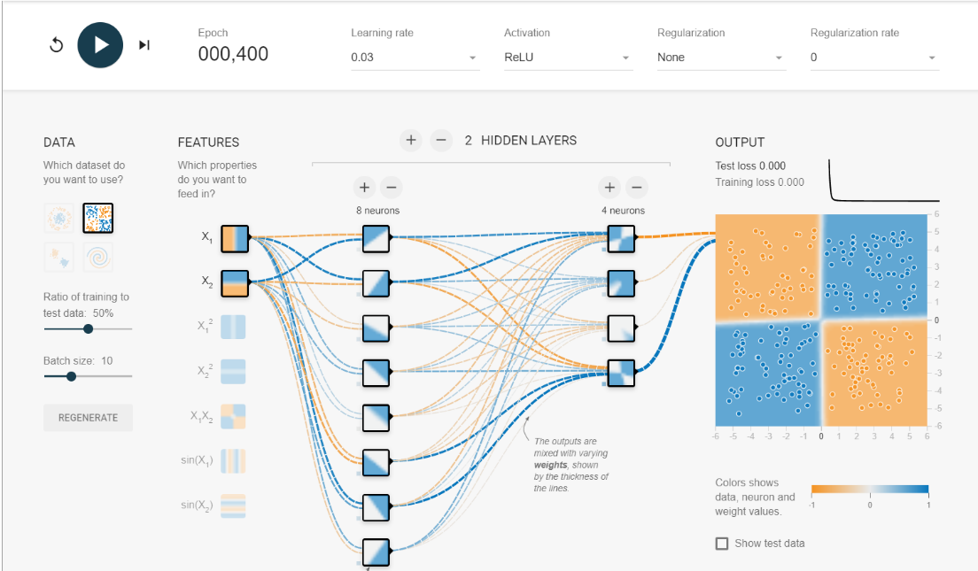

Extra

8 6 6 relu

